**Answer 1:**

#include <stdio.h>

int main()

{

int i, j, row, col, cnt=0, den=0, density=0, sparse=0;

printf("Input the rows of the matrix: ");

scanf("%d", &row);

printf("Input the columns of the matrix: ");

scanf("%d", &col);

int mat[row][col];

for(i=0; i<row; i++)

{

for(j=0; j<col; j++)

{

printf("Input the elements of the matrix, disp[%d][%d]: ", i, j);

scanf("%d", &mat[i][j]);

if(mat[i][j]==0)

{

cnt++;

}

else{

den++;

}

}

}

printf("Number of zeroes %d.\n", cnt);

sparse=(cnt*100)/(row*col);

printf("The sparsity of the matrix is %d percent.\n", sparse);

density=(den*100)/(row*col);

printf("Number of non zero elements is %d.", density);

}

**Output:**

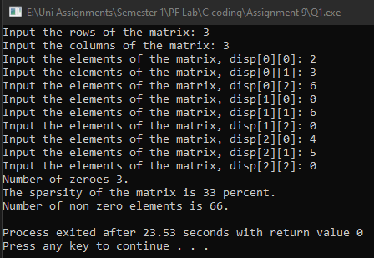

**Answer 2:**

#include <stdio.h>

int main()

{

int row, col, i, j, swap;

printf("Input the number of rows: ");

scanf("%d", &row);

printf("Input the number of columns: ");

scanf("%d", &col);

if(i==j)

{

int mat[row][col];

for(i=0; i<row; i++)

{

for(j=0; j<col; j++)

{

printf("Input the number of elements disp[%d][%d]: ", i, j);

scanf("%d", &mat[i][j]);

}

}

}

else{

int mat[row][col];

swap=row;

row=col;

col=swap;

for(i=0; i<row; i++)

{

for(j=0; j<col; j++)

{

printf("Input the number of elements disp[%d][%d]: ", i, j);

scanf("%d", &mat[i][j]);

}

}

printf("The transposed matrix is:\n");

for(i=0; i<row; i++)

{

for(j=0; j<col; j++)

{

printf("%d ", mat[i][j]);

}

printf("\n");

}

}

//for transpose.

// for(i=0; i<row; i++)

// {

// for(j=0; j<col; j++)

// {

// trans[i][j]=mat[i][j];

// }

// }

}

**Output:**

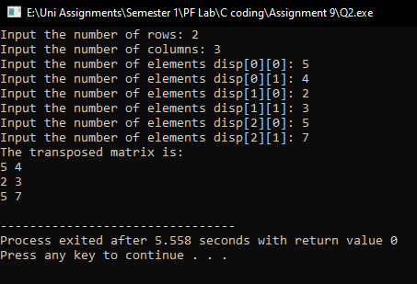

**Answer 5:**

#include <stdio.h>

#include <math.h>

float add(float res);

float sub(float res);

float div(float res);

float mult(float res);

float power(float res);

int main()

{

char choice;

float res;

printf("Input the choice (+, -, *, /, p): ");

scanf("%c", &choice);

switch(choice)

{

case '+':

res=add(res);

printf("The result is = %.2f", res);

break;

case '-':

res=sub(res);

printf("The result is = %.2f", res);

break;

case '*':

res=mult(res);

printf("The result is = %.2f", res);

break;

case '/':

res=div(res);

printf("The result is = %f", res);

break;

case 'p':

res=power(res);

printf("The result is = %.1f", res);

break;

default:

printf("Enter a valid choice.");

return 0;

break;

}

}

float power(float res)

{

float num1, num2;

printf("Enter the number: ");

scanf("%f", &num1);

printf("Enter the superscript: ");

scanf("%f", &num2);

res=pow(num1,num2);

return res;

}

float div(float res)

{

float num1, num2;

printf("Enter first number: ");

scanf("%f", &num1);

printf("Enter second number: ");

scanf("%f", &num2);

res=num1/num2;

return res;

}

float mult(float res)

{

float num1, num2;

printf("Enter first number: ");

scanf("%f", &num1);

printf("Enter second number: ");

scanf("%f", &num2);

res=num1*num2;

return res;

}

float sub(float res)

{

float num1, num2;

printf("Enter first number: ");

scanf("%f", &num1);

printf("Enter second number: ");

scanf("%f", &num2);

res=num1-num2;

return res;

}

float add(float res)

{

float num1, num2;

printf("Enter first number: ");

scanf("%f", &num1);

printf("Enter second number: ");

scanf("%f", &num2);

res=num1+num2;

return res;

}

**Output:**

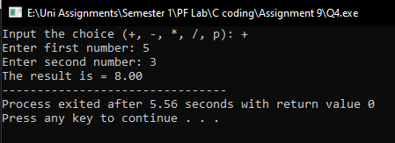

**Answer 6:**

#include <stdio.h>

#include <math.h>

float relu(float rel);

float sig(float e, float x);

int main()

{

float rel;

int ch;

float x=0, e=2.17, res=0;

printf("Press 1 for sigmoid and 2 for ReLu: ");

scanf("%d", &ch);

switch(ch)

{

case 1:

printf("Input the value of x: ");

scanf("%f", &x);

res=sig(e,x);

printf("The value is %f", res);

break;

case 2:

printf("Input the value for ReLu: ");

scanf("%f", &rel);

relu(rel);

printf("ReLu is: %.2f", rel);

break;

default:

printf("Input a valid choice.");

break;

}

}

float relu(float rel)

{

if(rel<0)

{

printf("The value of ReLu cannot be less than 0.");

return 0;

}

else{

return rel;

}

}

float sig(float e, float x)

{

float res;

res=1/(1+exp(-x));

return res;

}

**Output:**

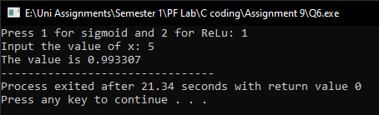

**Answer 7 & 8 & 9:**

#include <stdio.h>

#include <math.h>

int q1(int q);

int p1(int p);

int gcd(int n, int k, int e);

int ran(int k, int e);

int encstr();

int intdec();

int main()

{

char arr[100];

int i, l;

int ch, p=0, q=0, n, k, e=0, d, h[100];

unsigned long long int c[100], m[100];

printf("Press 1 for encryption and 2 for decryption: ");

scanf("%d", &ch);

switch(ch)

{

case 1:

printf("Input the number of characters in string: ");

scanf("%d", &l);

for(i=0; i<l; i++)

{

printf("Input a character: ");

scanf("%s", &arr[i]);

h[i]=arr[i]-65;

}

p=p1(p);

q=q1(q);

k=(p-1)*(q-1);

n=p*q;

printf("Input an encryption key: ");

scanf("%d", &e);

gcd(n,k,e);

d=ran(e,k);

for(i=0; i<l; i++)

{

m[i]=pow(h[i], e);

c[i]=m[i]%n;

printf("Bob sends %llu\n", c[i]);

}

break;

}

}

int ran(int e, int k)

{

int d=0;

printf("Input a random number: ");

scanf("%d", &d);

d=(e*d)%k;

if(d==1)

{

return d;

}

else{

printf("Wrong random.\n");

ran(e,k);

}

}

int gcd(int n, int k, int e)

{

int exh, g;

if(k>e)

{

exh=e;

e=k;

k=exh;

}

while(k!=0)

{

g=e%k;

e=k;

k=g;

}

if(e==1)

{

return 1;

}

}

int p1(int p)

{

int i, k, j, alg;

for(i=7; i<=1000; i++)

{

k=0;

for(j=1; j<=i-1; j++)

{

alg=i%j;

if(alg==0)

{

k++;

}

}

if(k==1)

{

p=i;

return p;

}

}

}

int q1(int q)

{

int i, k, j, alg;

for(i=11; i<=1000; i++)

{

k=0;

for(j=1; j<=i-1; j++)

{

alg=i%j;

if(alg==0)

{

k++;

}

}

if(k==1)

{

q=i;

return q;

}

}

}

**Output:**

